

ABOUT COUNTRY CLUSTERING BUSINESS

The main objective of this project is to analyse and group countries based on their socio-economic and health-related factors using clustering techniques.
An international NGO has limited resources and needs to identify which countries require urgent attention and support. By analysing important indicators such as income, GDP, child mortality rate, life expectancy, and healthcare expenditure, we can segment countries into different meaningful clusters.
Clustering helps to divide countries into similar categories like:
- Underdeveloped countries
- Developing countries
- Developed countries
This project focuses on providing data-driven insights that will help the NGO to:
- Prioritize resource allocation
- Make better and informed decisions
- Design effective strategies for country development
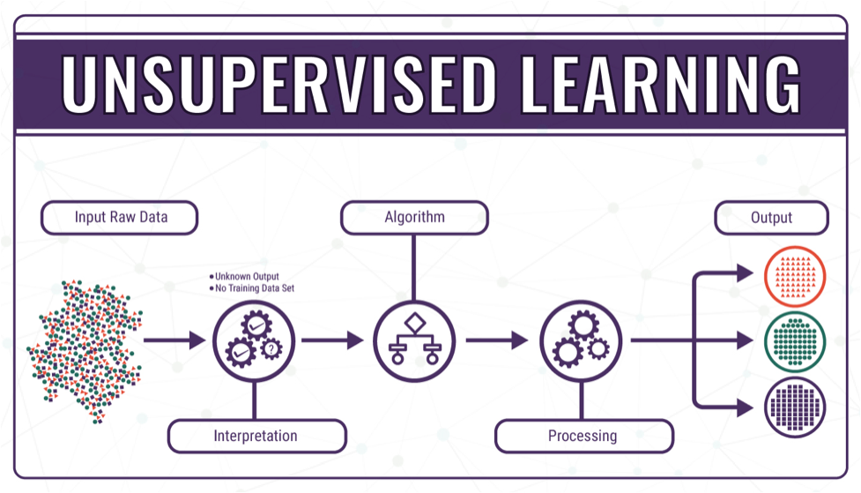

PROBLEM STATEMENT
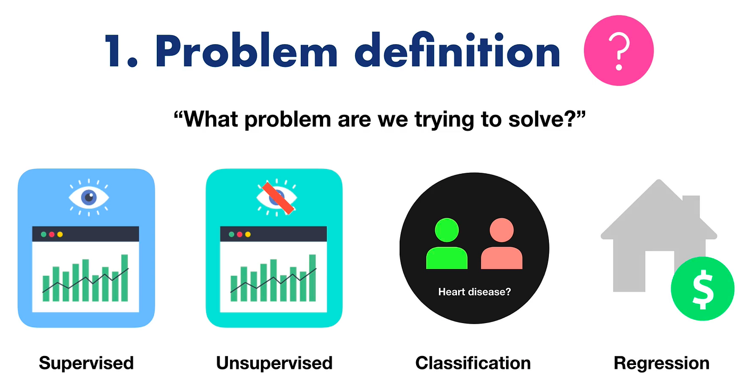
- An international NGO works with many countries
- The NGO has limited funds and resources
- It is difficult to support all countries equally
- Countries differ in:
  - Income
  - GDP per capita
  - Child mortality
  - Life expectancy
  - Health expenditure
- Manual analysis is time-consuming and complex
The NGO needs to:
- Identify countries that need urgent help
- Group similar countries together
Main Challenge:
- Prioritize countries based on their condition
Solution:
- Use clustering techniques
- Segment countries into meaningful groups
Final Goal:
- Efficient fund allocation
- Better decision-making

DATASET SOURCES
Dataset: country-data-csv
Source:https://1drv.ms/x/c/a48c01fec5c3c6a6/IQDuwhfW9U-9Qp2FOYpLtiJ_Adfen4dtPsiOS7YEAUqp4ho?e=6qRwTu

BUSINESS BACKGROUND

- An international NGO works with multiple countries across the world
The main goal of the NGO is to improve:
- Economic conditions
- Health facilities
- Social development
- The NGO has limited funding and resources
- It cannot provide equal support to all countries

Different countries have different levels of development:
- Some are developed
- Some are developing
- Some are underdeveloped
- The NGO needs a data-driven approach to make decisions

There is a need to:
- Identify countries with poor conditions
- Understand development levels of each country

The dataset provides important indicators like:
- Income
- GDP
- Child mortality
- Life expectancy
- Health spending
By analysing this data, the NGO can:
- Prioritize countries for funding
- Allocate resources effectively
- Plan better development strategies

BUSINESS UNDERSTANDING
Business problem
- The NGO has limited funds and resources
- It cannot support all countries equally
- Needs to identify countries that require urgent help
- Difficult to analyse many countries manually
- Goal: Prioritize countries based on their condition

Clustering appropriate
- Clustering groups similar countries together
- No predefined labels needed (unsupervised learning)
- Helps to identify hidden patterns in data
- Easy to divide countries into:
  - Developed
  - Developing
  - Underdeveloped

Clustering helps fund allocation
- Identifies most needy countries (high mortality, low income)
- Helps NGO focus on high-priority clusters
- Enables efficient use of limited funds
- Supports data-driven decision making
- Improves overall impact of development programs

FEATURES
The dataset contains multiple socio-economic and health-related indicators for different countries.
- country: Name of the country (categorical feature, used only for identification)
- child mort: Number of deaths of children under 5 years per 1000 live births (indicates health condition)
- exports: Percentage of goods and services exported (shows economic activity)
- health: Total health expenditure as a percentage of GDP (indicates healthcare investment)
- imports: Percentage of goods and services imported (economic dependency)
- income: Net income per person (important economic indicator)
- inflation: Annual growth rate of GDP (economic stability)
- life expect: Average life expectancy (overall health condition)
- total fer: Number of children per woman (population growth indicator)
- GDPP: GDP per capita (overall economic strength)

DATA UNDERSTANDING

- The dataset represents country-level data where each row corresponds to a country and each column represents a development indicator
- The features can be categorized into:
Economic Indicators:
- income
- GDPP
- exports
- imports
Health Indicators:
- child mort
- health
- life expect
Social Indicators:
- total fer
- This classification helps in understanding how different aspects contribute to a country's development

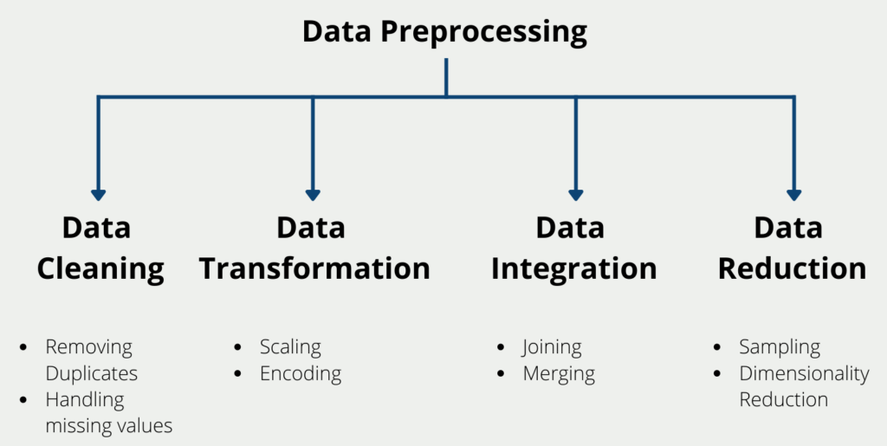
Before applying clustering, the dataset needs to be cleaned and prepared:
- Checked for missing values and handled them appropriately
- Removed duplicate records to avoid bias
- Converted data into proper formats if needed
- Removed irrelevant features like country name for clustering
- Applied feature scaling to normalize the data
- These steps ensure that the dataset is clean and suitable for analysis
- Handled outliers using methods like IQR or Z-score to reduce their impact on clustering
- Checked data distribution (skewness) and applied transformations if needed (log / normalization)
- Verified data consistency (no incorrect or unrealistic values)
- Ensured all features are in numerical format for clustering algorithms
- Performed feature correlation analysis to avoid highly correlated variables
- Removed redundant features that do not add value to clustering
Standardized data using techniques like:
- Standard Scale, Min Max Scaler

FEATURE SCALING

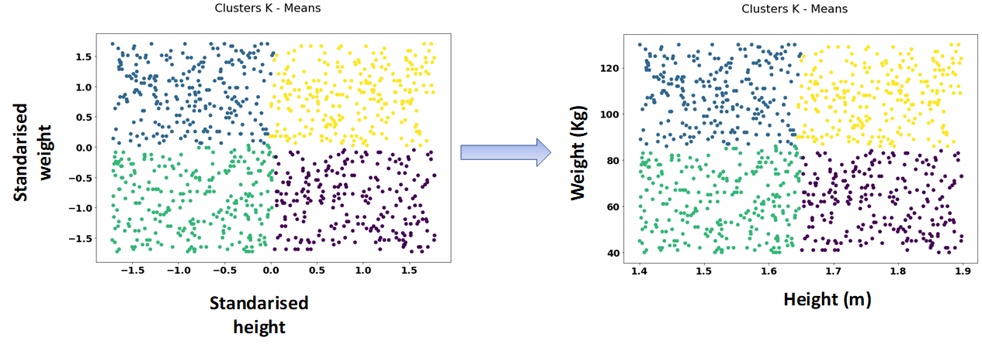

- Feature scaling is a critical step in clustering because:
- The dataset contains features with different units and ranges
- Example: income values are very large
- child mortality values are small

- Without scaling:
- Features with larger values dominate clustering
- Results become biased

- Scaling ensures:
- All features contribute equally
- Distance-based algorithms like K-Means perform accurately

EXPLORATORY DATA ANALYSIS (EDA)
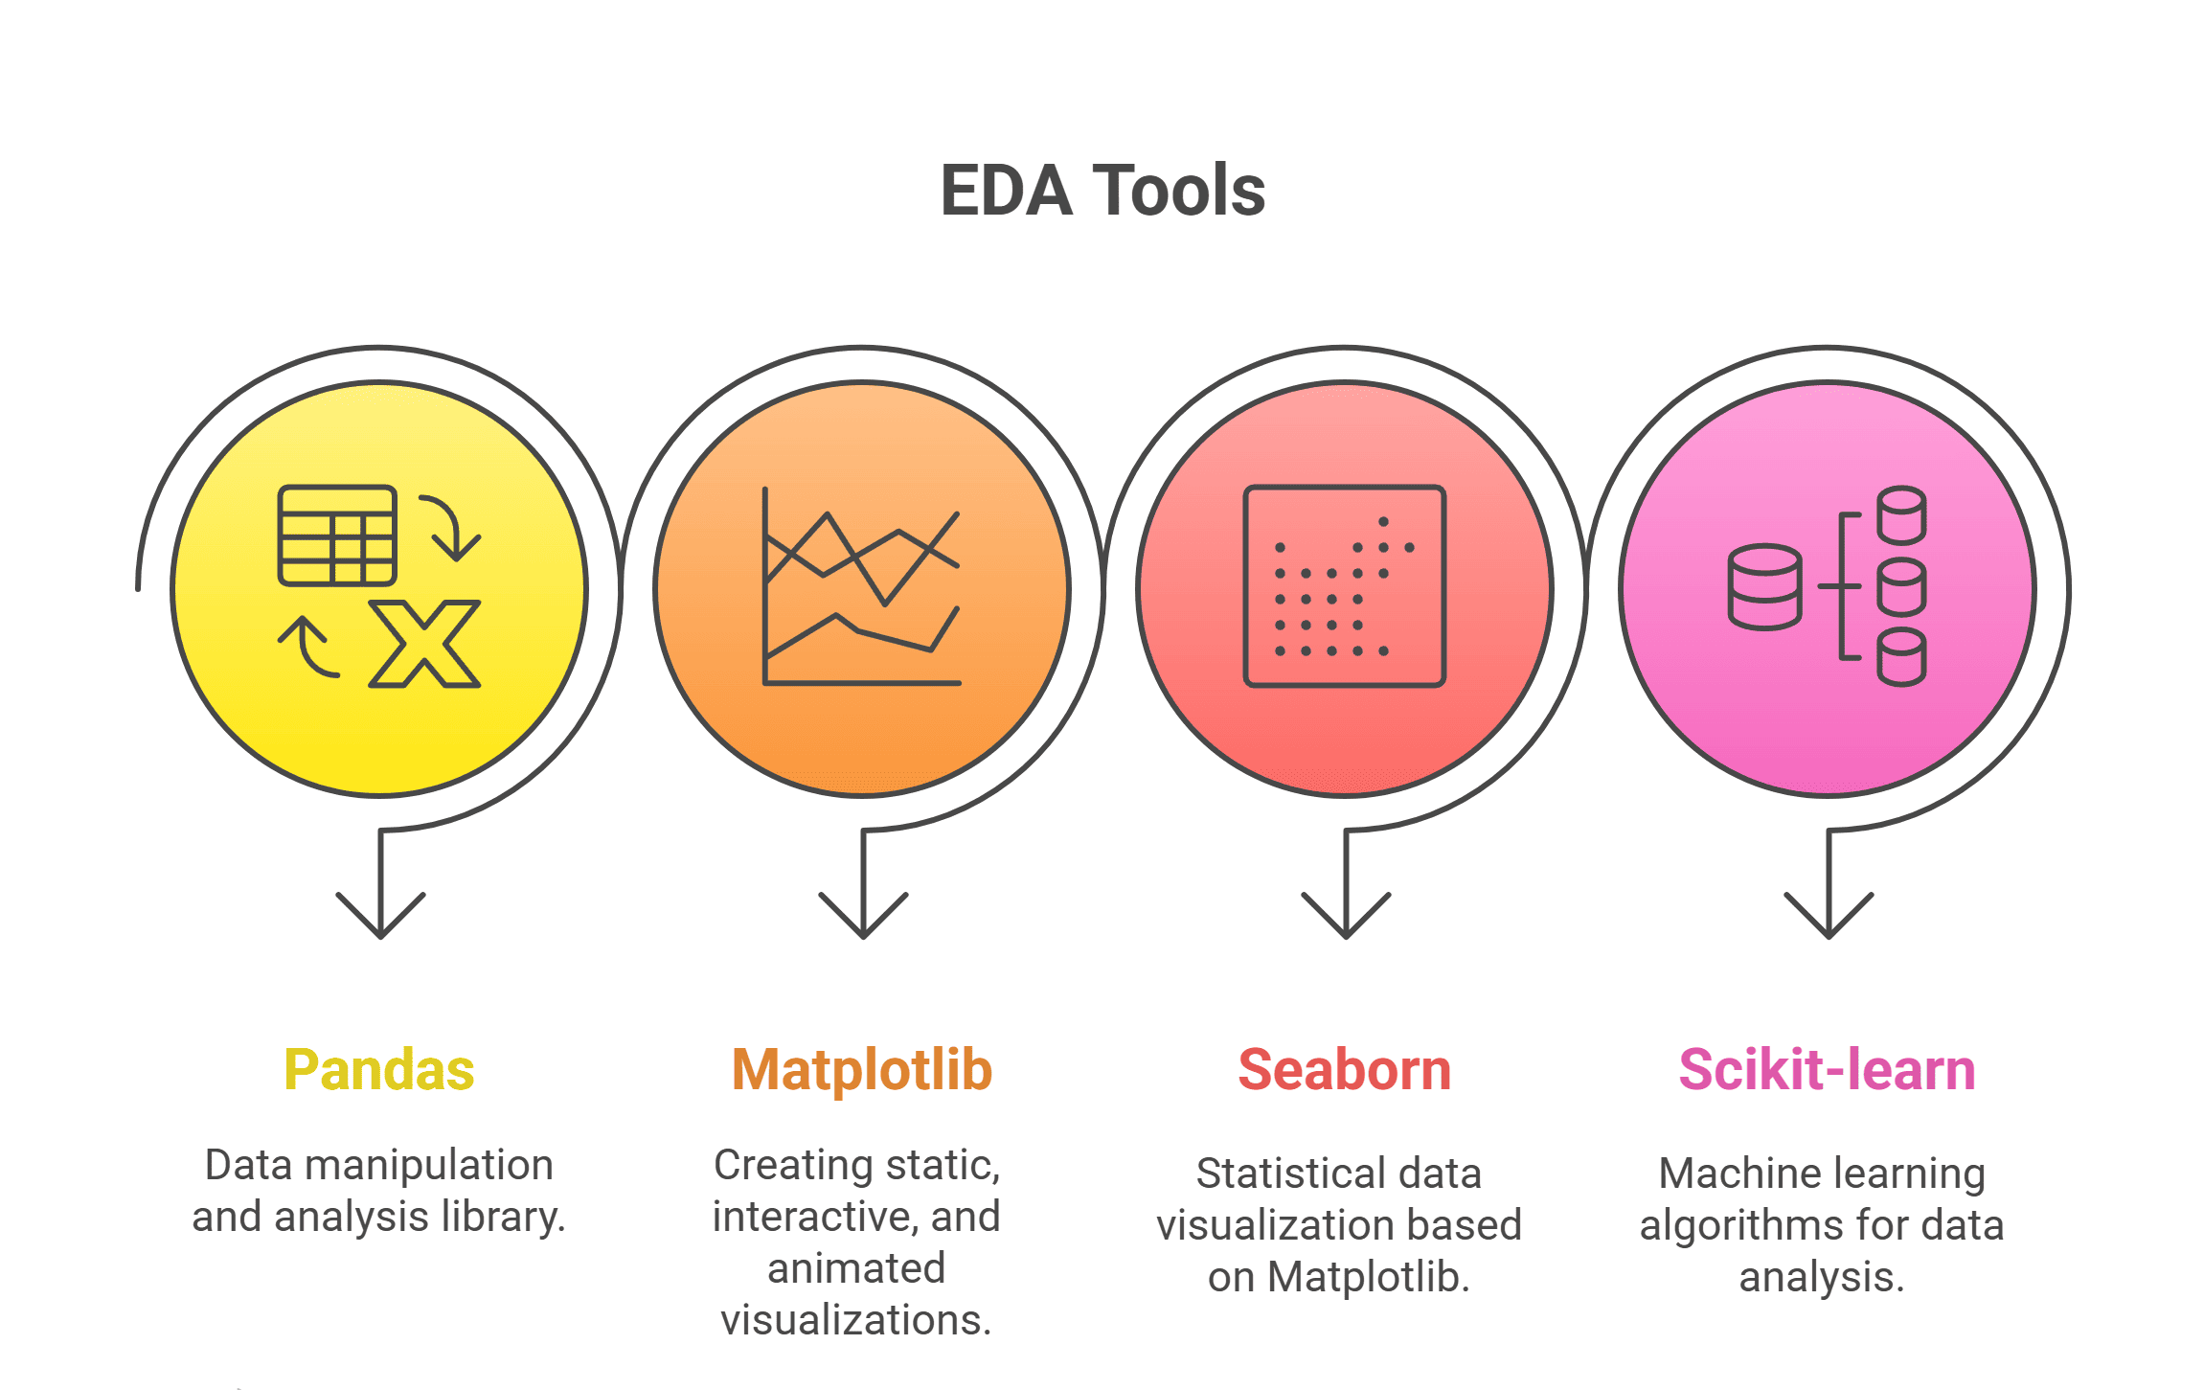
- EDA helps in understanding patterns and relationships in the dataset
- Analysed distributions of:
  - Income
  - Child mortality
  - Life expectancy
Observations:
- High income and high life expectancy → developed countries
- High child mortality and low income → underdeveloped countries
- Identified outliers and extreme values
- Helped in forming initial assumptions about country groups

FEATURE SELECTION
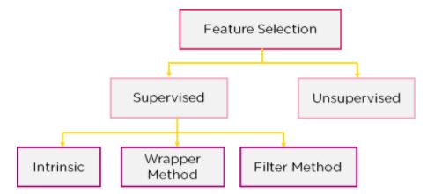

Feature selection is the process of choosing the most important variables (features) from a dataset that are useful for building a model.
- Improves model performance
- Reduces complexity
- Removes irrelevant or duplicate data
- Saves time and computation
- Helps in better understanding of data
Selected Features:
- income
- GDPP
- child mort
- life expect
- health
Removed Features:
- country (non-numeric, not useful for clustering)
Reason:
- Selected features directly reflect economic condition, health status, and development level, which align with the project objective
ALOGRITHMS
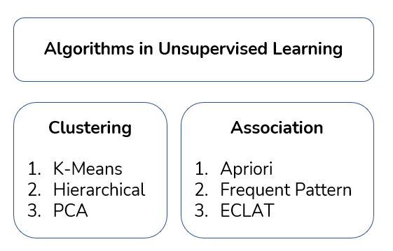
K-Means clustering is used in this project because:
- It is simple and easy to implement
- Works efficiently on numerical data
- Suitable for large datasets
- Groups data into K clusters based on similarity
- The algorithm minimizes the distance between data points within a cluster
Clustering Process
- Applied K-Means algorithm on scaled data
- Determined optimal number of clusters using:
  - Elbow Method
  - Silhouette Score
- Final clusters represent groups of countries with similar characteristics

CLUSTER PROFILING

Cluster 1 (Developed):
- High income
- High life expectancy
- Low child mortality
Cluster 2 (Developing):
- Moderate income
- Moderate health indicators
Cluster 3 (Underdeveloped):
- Low income
- High child mortality
- Low life expectancy
- This helps in understanding the characteristics of each group

Visualization
- Visualization is used to represent clusters clearly:
- Scatter plots show separation between clusters
- Graphs help identify:
  - Group patterns
  - Outliers
- Visualization makes it easier for stakeholders to understand results

INSIGHTS

- Countries with low income and high mortality are underdeveloped
- Countries with high income and long-life expectancy are developed
- Clear segmentation of countries is achieved

RECOMEDATIONS
- NGO should prioritize underdeveloped countries
- Provide:
  - Healthcare support
  - Education facilities
  - Economic development programs
- Developing countries should receive growth support
- Developed countries require minimal intervention

LIMITATIONS
- Dataset contains limited features
- Clustering depends on chosen K value
- Results may vary with different data
- External factors like politics are not considered

CONCLUSION

- Clustering successfully grouped countries based on development indicators
- Provided clear insights for decision-making
- Helps NGO in:
  - Efficient fund allocation
  - Strategic planning
- Overall, the project demonstrates how data science can support real-world decision-making

